Introduction to Redux

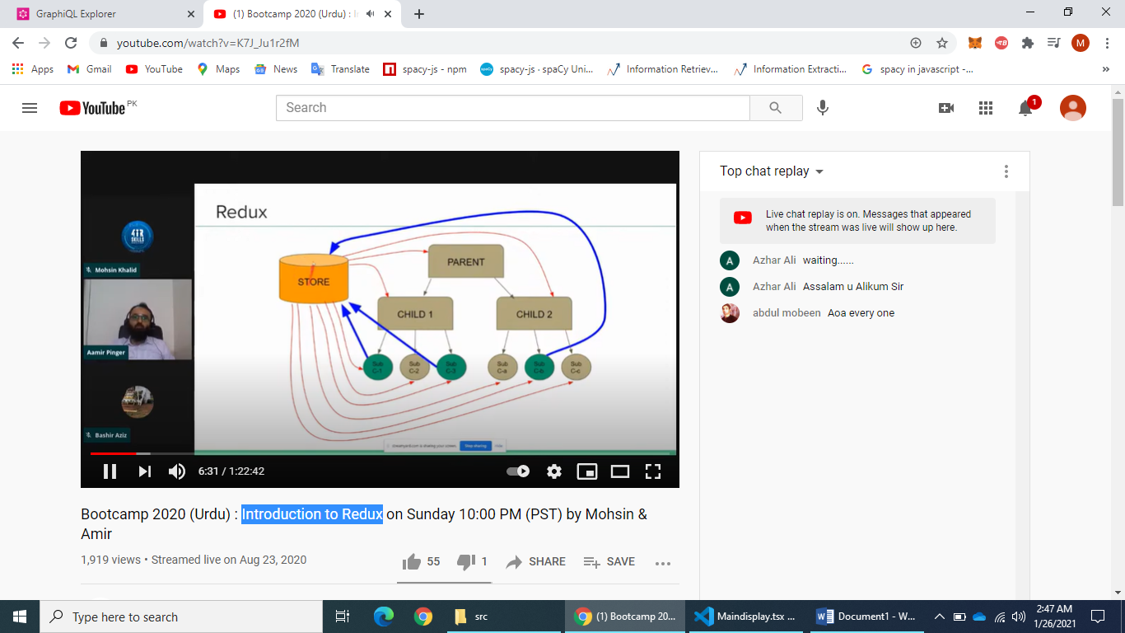

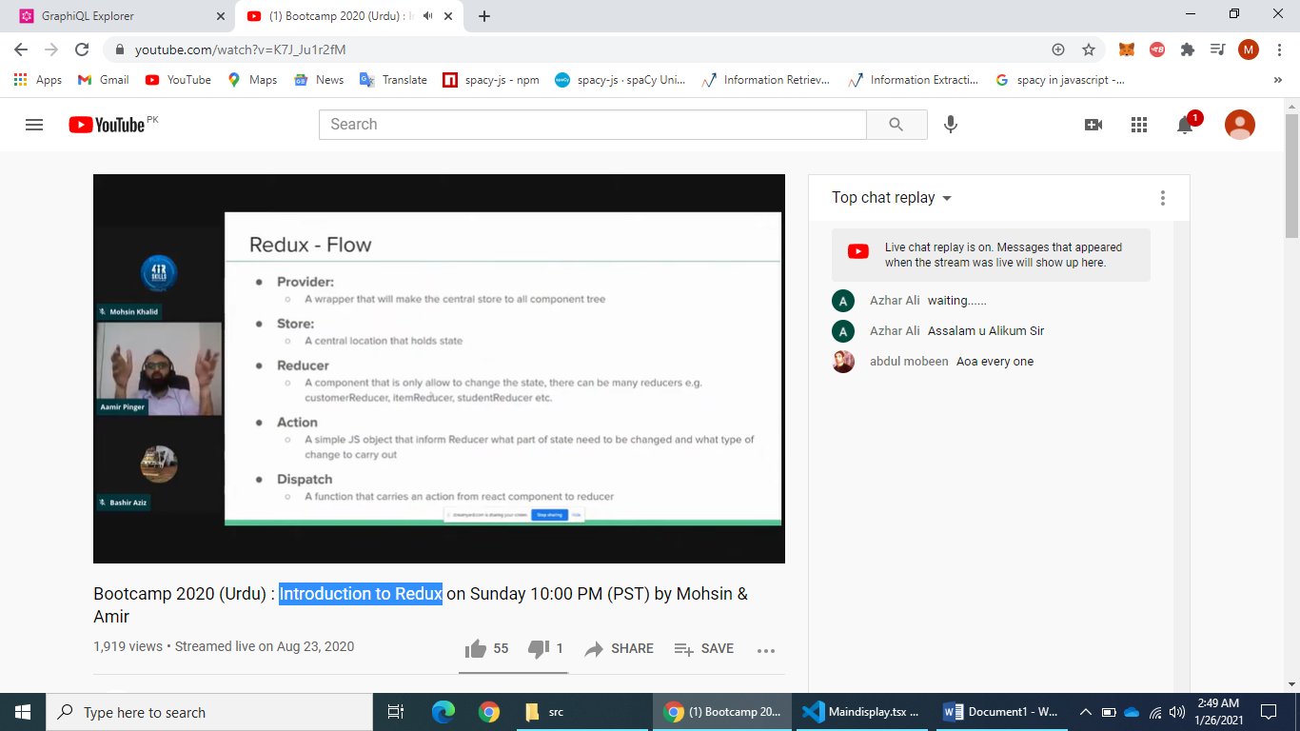

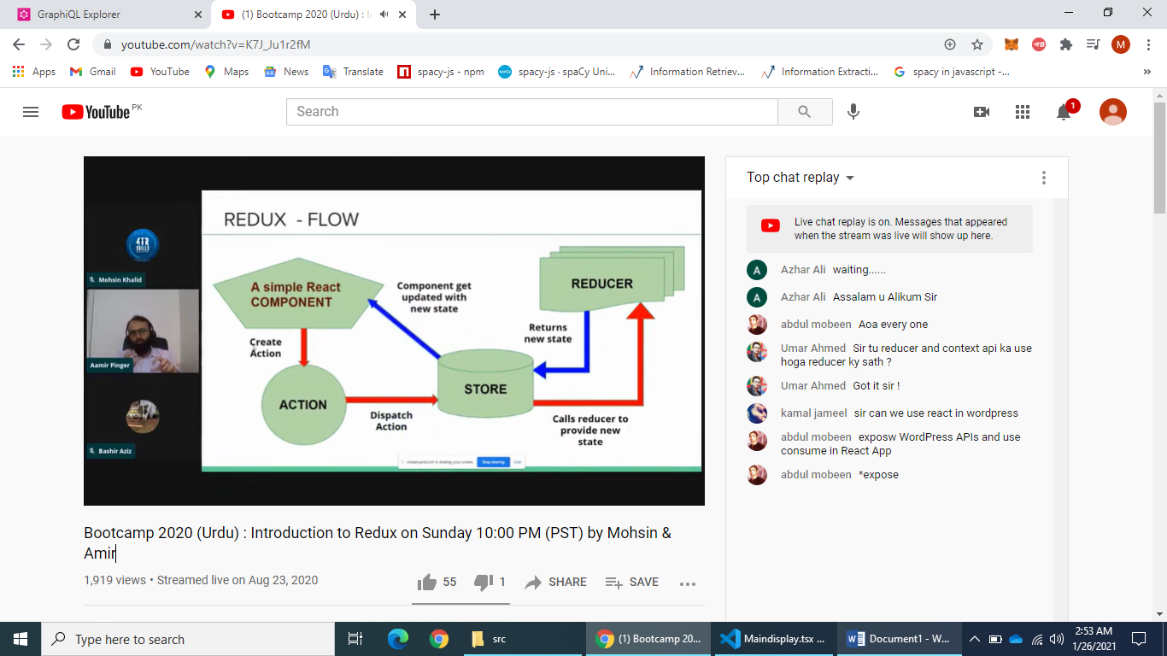

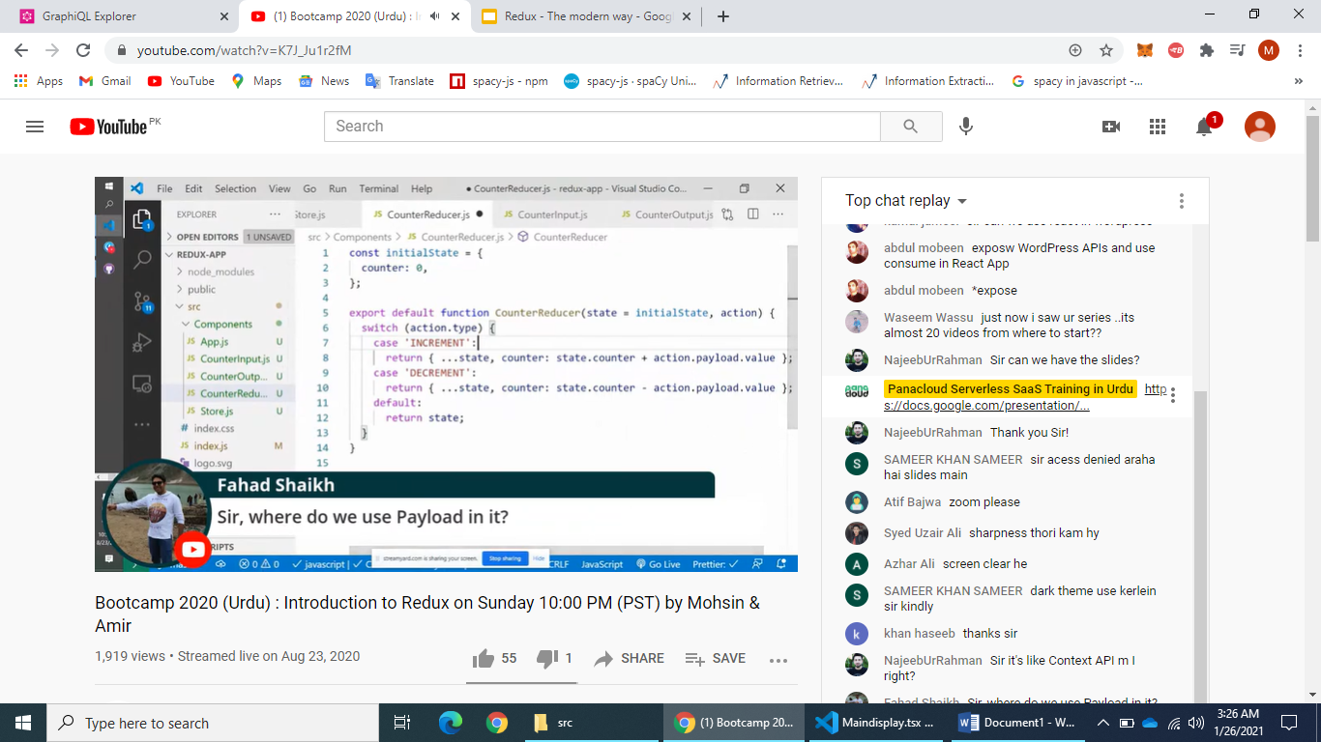

IMSTALL:

npm i redux react-redux

SLIDE LINK:

<https://docs.google.com/presentation/d/1AYPOmQ-5PgoCnasjZ3qMo_LCHp2jo0kxFlLHnP2dkaA/edit#slide=id.g946dbafdc4_0_485>

STEP:

1. Make project
2. Intall redux
3. Make store.js
4. Make Action file
5. Add provider in index.js
6. Make files and use this
7. Likin ek masla hain humen INCREMENT he lekha pare ga for increment
8. For this make action creater file

RESET IN REDUX:

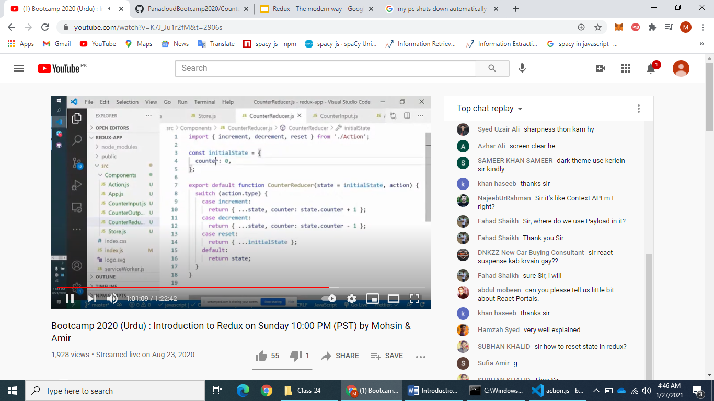

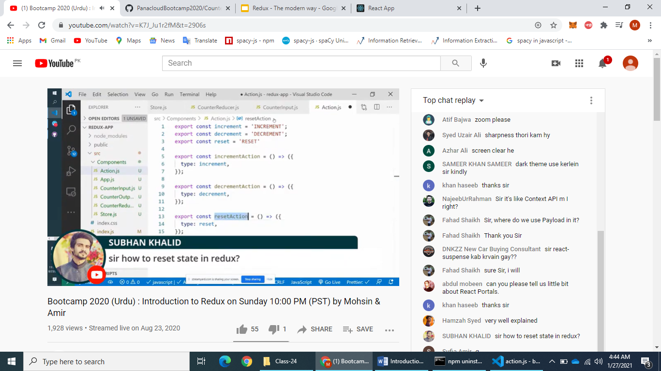

**REDUX TOOL KIT:**

EK STANDER TAKEA BANA YA TAKE SAB DEVELOPER KE LEA SAME RAHE

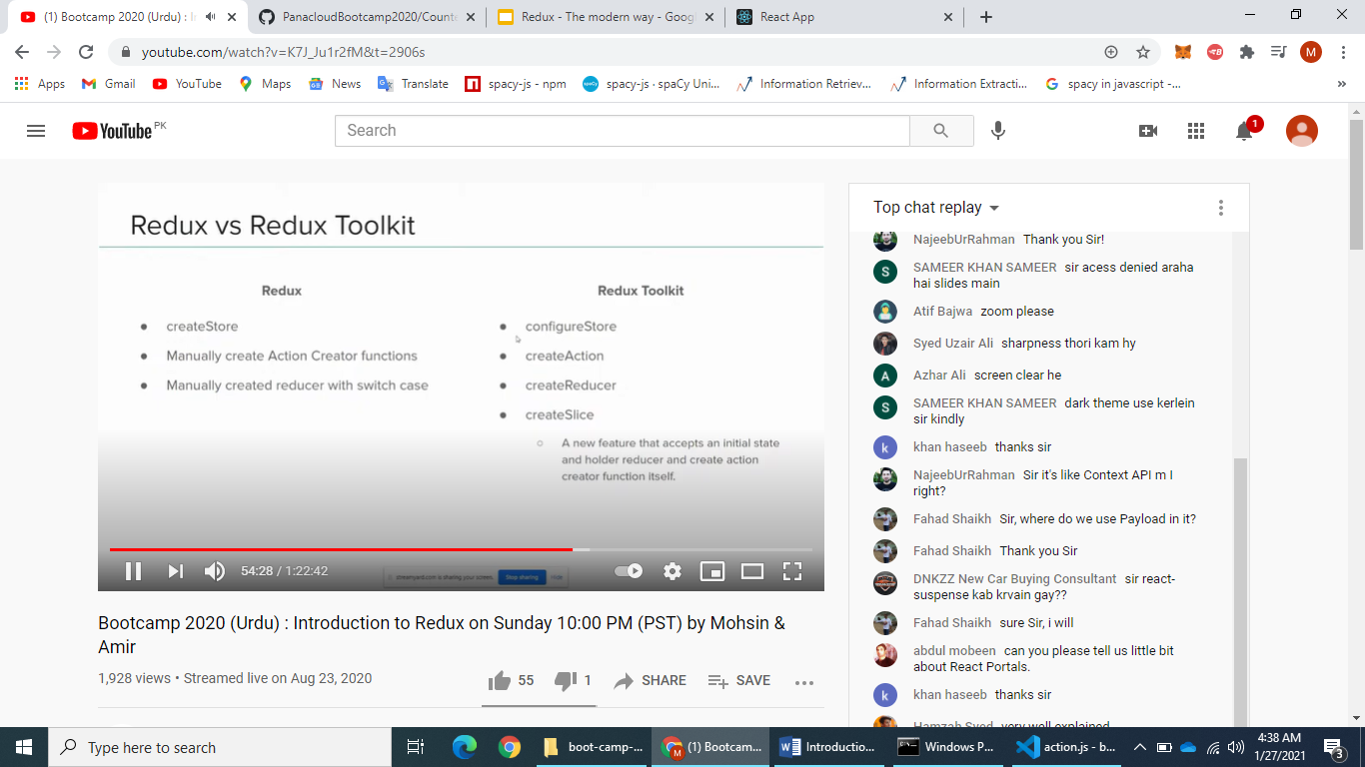

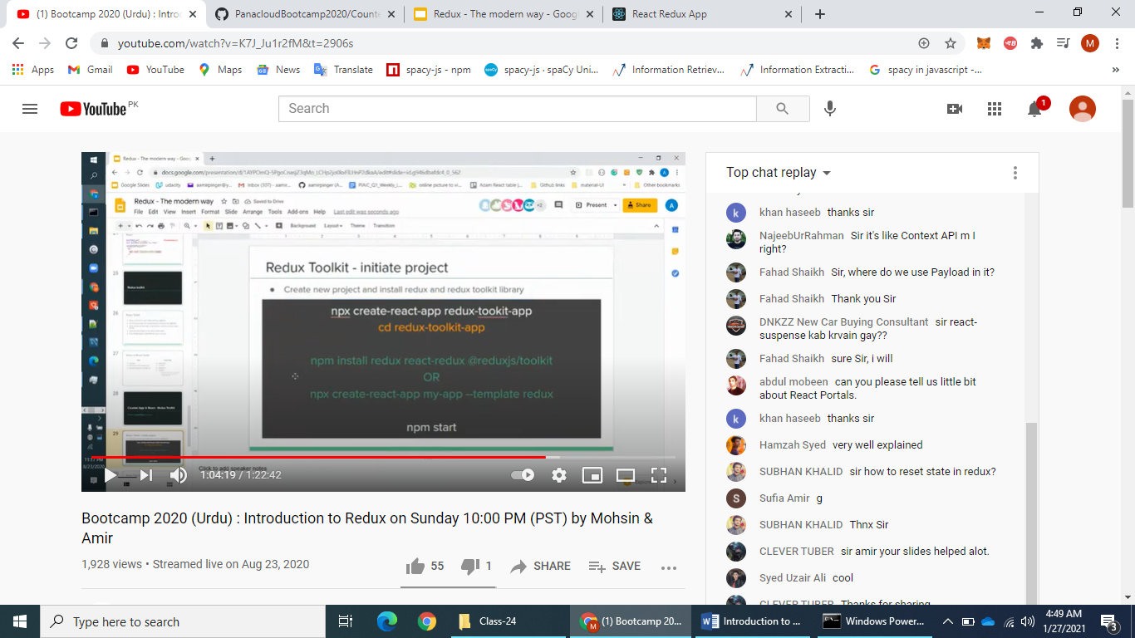 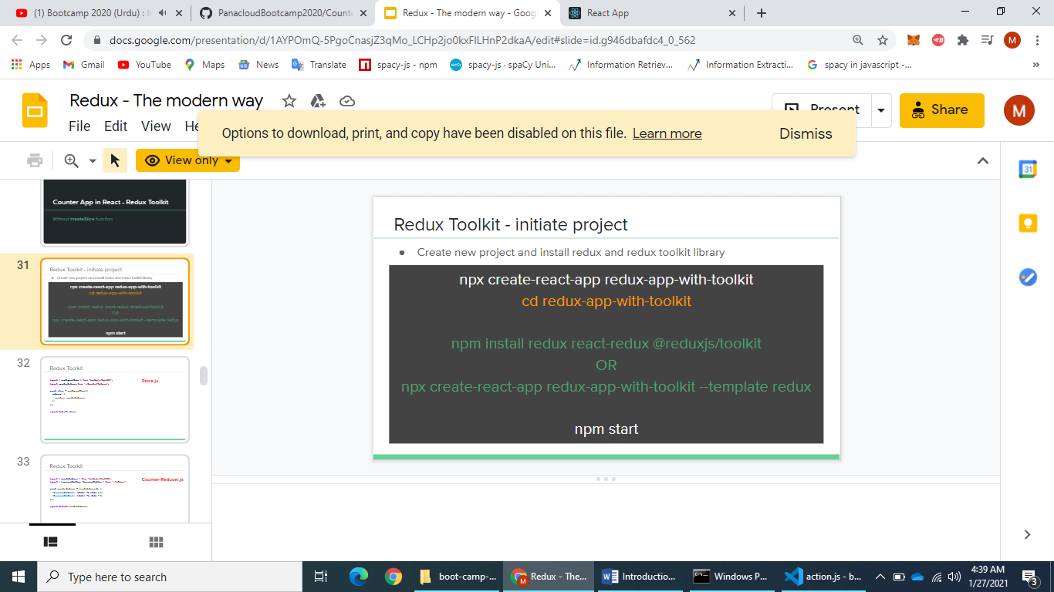

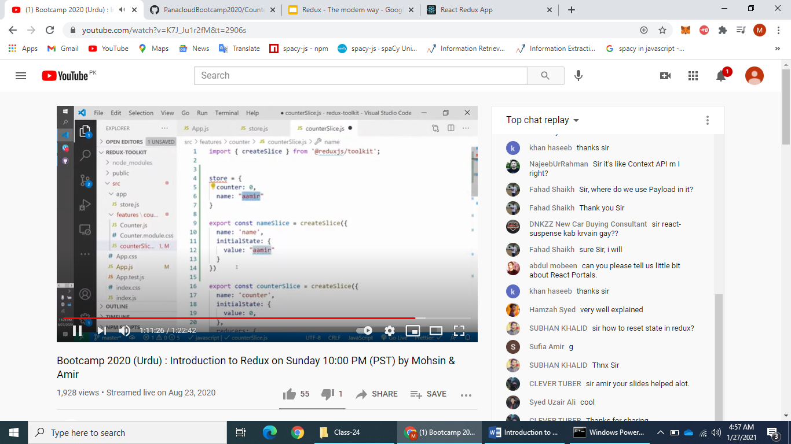

SLIDE:

https://docs.google.com/presentation/d/1AYPOmQ-5PgoCnasjZ3qMo_LCHp2jo0kxFlLHnP2dkaA/edit#slide=id.g946dbafdc4_0_609